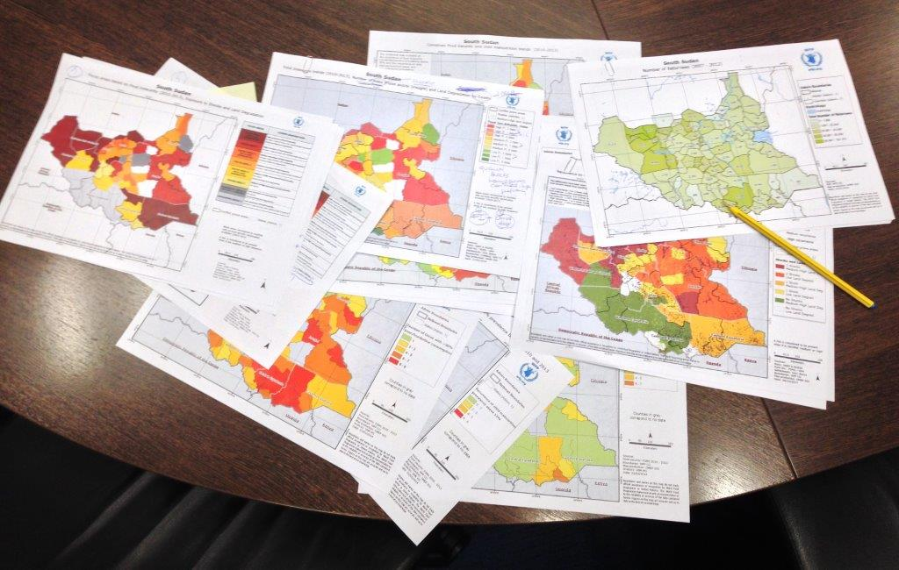



**Integrated Context Analysis (ICA)**

**Technical Paper**

**Short Country Name**

Month year

<Optional: Insert picture relevant to food security in the country, PNG format and maximum file size of 500MB>

**WFP Short Country Name**

Street address | City | Postal Code | Country

For more information, including access to the ICA Programmatic Interpretations and Conclusions Paper, please contact:

* **WFP Short Country Name:** Name of contact | Title | email
* **WFP Regional Bureau:** Name of contact | Title | email
* **WFP Headquarters**: Kevin Wyjad | ICA Coordinator | [kevin.wyjad@wfp.org](mailto:kevin.wyjad@wfp.org)

© **United Nations World Food Programme (WFP)**

Via Cesare Giulio Viola 68/70 | 00148 Rome, Italy | <http://www.wfp.org/>

**Table of Contents**

1. Introduction 4

2. ICA Categories 5

3. ICA Areas 6

4. Food Security Analysis 7

5. Natural Shock Risk Analysis 8

Floods 9

Drought 10

6. ICA Lenses 11

Land Degradation Lens 12

Landslide Risk Lens 13

Nutrition Lens 14

Additional Lens 15

7. Additional Contextual Information 16

Population Distribution 16

Inter-Annual Variability of Food Insecurity 17

Intra-Annual Variability of Food Insecurity 19

Seasonality of Natural Shocks 20

Livelihoods 21

8. Estimated Numbers of Food Insecure People 22

Food Insecure Population for Long-Term Planning 23

Food Insecure Population for Preparedness 24

9. Technical Analysis Methodology 25

Food security 25

Rapid-onset shocks 25

Slow-onset shocks 25

Land degradation 26

Nutrition 27

Livelihoods 27

Variability 27

10. Data Sources 29

11. Data tables 30

Final ICA Collecting Table 30

Nutrition Data Table 31

# Introduction

This report provides the technical analysis of the Integrated Context Analysis (ICA) in Country, and complements the ICA Programmatic Interpretation and Conclusions by providing an evidentiary basis for discussions on what broad programmatic strategies are appropriate for different parts of the countries. The ICA Programmatic Interpretation and Conclusions is/will be available as a separate document.

The Integrated Context Analysis (ICA) is an analytical process that contributes to the identification of broad national programmatic strategies, including resilience building, disaster risk reduction, and social protection for the most vulnerable and food insecure populations.

The ICA is based on principles of historical trend analyses across a number of technical and sectorial disciplines, the findings of which are overlaid to identify areas of overlap. Trend analyses provide an understanding of what has happened in the past and what may (or may not) be changing to act as a proxy for what may occur in the future, and where short, medium, and longer term programming efforts may be required. It is based on two core factors: trends of food insecurity and main natural shocks (droughts and floods).

By overlaying these findings on each other, combinations of recurring food insecurity and shock risk can be identified, and in turn the combinations of broad programmatic strategies that may be required to address these in a more holistic manner, drawing on the comparative advantages and technical expertise of governments, partners, communities, and of affected populations themselves.

Beyond the core ICA factors above, additional layers related to subjects that are relevant to programme strategies (e.g. landslide risk, land degradation, nutrition) can be overlaid as lenses to support further strategic adjustments. The ICA can also be used to identify areas where further in-depth studies or food security monitoring and assessment systems are needed. When used as part of WFP’s Three Pronged Approach (3PA) the ICA can guide the identification of priority areas in which to conduct Seasonal Livelihood Programming (SLP) consultations to identify area-specific complementary and multi-sectorial programmes with governments and partners, which in turn set the foundations for targeted joint efforts with communities and partners to plan and implement programmes through Community-Based Participatory Planning (CBPP).

### Partnerships

The following agencies, organisations and government bodies contributed to this report:

* <insert agency names in list, alphabetically>

# ICA Categories

|  |
| --- |
| <insert ICA Categories map here: Exact dimensions 17 cm width x 12 cm height, maximum file size 500kb; use PNG format, not JPEG> |

The ICA categorises the country’s Administrative levels/boundary into Categories 1 to 5 based on their levels of recurring food insecurity and exposure to natural shocks. This is done by combining some of the ICA Areas on the previous page, as shown in the table below, such that the nine Areas become five Categories. The ICA Categories and areas provide evidence for broad programmatic strategies and discussion with partners.

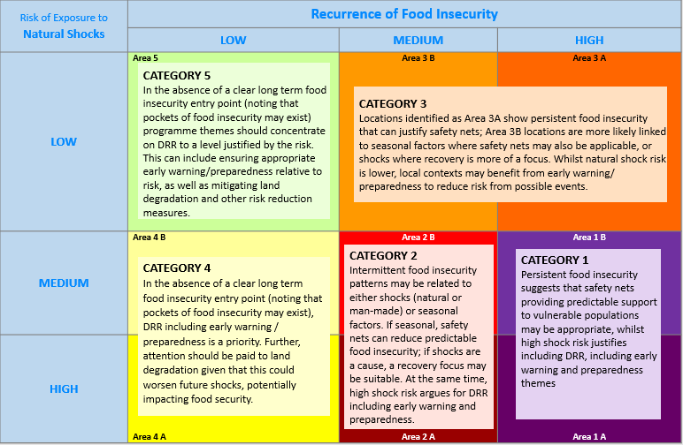

# ICA Areas

|  |
| --- |
| <insert ICA Areas map here: Exact dimensions 17 cm width x 12 cm height, maximum file size 500kb; use PNG format, not JPEG> |

The ICA areas map is created by combining for each Administrative levels/boundary the three-point scale values for food security and natural shock risk shown on the following two pages. The high/medium/low values are cross-tabbed, producing the nine area types shown in the table below.

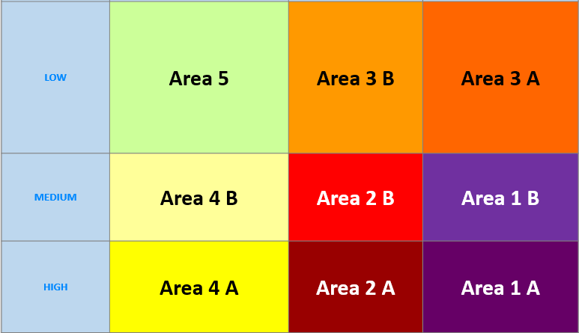

# Food Security Analysis

|  |
| --- |
| <insert food security map here: Exact dimensions 17 cm width x 12 cm height, maximum file size 500kb; use PNG format, not JPEG> |

|  |
| --- |
| The food security analysis was carried out using data from source. The data was available from Month, Year through Month, Year. In most years data was collected frequency of rounds (once, twice, thrice, etc.) a year, such that in total number of rounds were available. For the purposes of the analysis, data was aggregated by level of aggregation, which in Country are called name of level (province, district, ward, etc.).  It should be noted that: data caveats/limitations/gaps/sampling issues, etc.  The key indicator utilised for the analysis was the indicator. The food security threshold was set at threshold level considering the fact that contextual justification. Areas were classified considering the number of times the indicator value was above the threshold. |

# Natural Shock Risk Analysis

|  |
| --- |
| <insert natural hazards map here: Exact dimensions 17 cm width x 12 cm height, maximum file size 500kb; use PNG format, not JPEG> |

|  |  |  |  |  |  |  |  |  |  |  |  |  |  |  |  |  |  |  |  |  |  |  |  |  |  |  |  |  |  |  |  |  |
| --- | --- | --- | --- | --- | --- | --- | --- | --- | --- | --- | --- | --- | --- | --- | --- | --- | --- | --- | --- | --- | --- | --- | --- | --- | --- | --- | --- | --- | --- | --- | --- | --- |
| The natural shocks analysis was carried out using data on list hazards included. Data for each of these shocks was analysed by level of aggregation which in Country name is called name of level (province, district, ward, etc.   |  |  |  |  | | --- | --- | --- | --- | | **Drought exposure** | | | | | **Flood exposure** | Low (1) | Medium (2) | High (3) | | Low (1) | Very Low | Low | Moderate | | Medium (2) | Low | Moderate | High | | High (3) | Moderate | High | Very High |   ⇩   |  |  |  |  | | --- | --- | --- | --- | | **Combined exposure by unit of analysis** | | | | | **Combined risk of natural shocks** | **2 - 3** | **4** | **5 - 6** | | ICA Reclassification | LOW (1) | MEDIUM (2) | HIGH (3) | |

## Floods

|  |
| --- |
| <insert flood map here: Exact dimensions 17 cm width x 12 cm height, maximum file size 500kb; use PNG format, not JPEG> |

|  |  |  |  |  |  |  |  |  |  |  |  |  |  |  |  |  |  |  |  |  |  |  |  |  |
| --- | --- | --- | --- | --- | --- | --- | --- | --- | --- | --- | --- | --- | --- | --- | --- | --- | --- | --- | --- | --- | --- | --- | --- | --- |
| Flood data was obtained from the source and was available from Year through Year. The original dataset was aggregated to the Administrative level (Admin01, Admin02). It should be noted that: data caveats/limitations/gaps/sampling issues, etc. The key indicator used was the indicator, with the range of values classified by the ICA as indicated below.   |  |  |  |  | | --- | --- | --- | --- | | **% of surface area affected** by **marz** | | | | | **% of surface area affected** | **2%** | **3 – 5%** | **> 5%** | | ICA Reclassification | LOW (1) | MEDIUM (2) | HIGH (3) |  |  |  |  |  | | --- | --- | --- | --- | | **Maximum frequency** by **marz** | | | | | **Maximum frequency** | **2 events** | **10 events** | **-** | | ICA Reclassification | LOW (1) | MEDIUM (2) | HIGH (3) | |

|  |  |  |  |
| --- | --- | --- | --- |
| **Flood exposure** by **marz** | | | |
| **Combined flood factors** | Low (1) | Medium (2) | High (3) |
| Low (1) | Very Low | Low | Moderate |
| Medium (2) | Low | Moderate | High |
| High (3) | Moderate | High | Very High |

⇩

|  |  |  |  |
| --- | --- | --- | --- |
| **Flood exposure** by **marz** | | | |
| **Flood exposure** (% territory affected x frequency) | **2** | **3** | **4** |
| ICA Reclassification | LOW (1) | MEDIUM (2) | HIGH (3) |

## Drought

|  |
| --- |
| <insert drought map here: Exact dimensions 17 cm width x 12 cm height, maximum file size 500kb; use PNG format, not JPEG> |

|  |
| --- |
| Drought data was obtained from the source and was available from Year through Year. The original dataset was aggregated to the Administrative level (Admin01, Admin02). It should be noted that: data caveats/limitations/gaps/sampling issues, etc. The key indicator used was the indicator, with the range of values classified by the ICA as indicated below. |

|  |  |  |  |
| --- | --- | --- | --- |
| **indicator** by **level of aggregation** | | | |
| **Indicator** | **Low value range** | **Medium value range** | **High value range** |
| ICA Reclassification | LOW (1) | MEDIUM (2) | HIGH (3) |

# ICA Lenses

ICA lenses provide information relevant to further refining programme strategies overlaid on top of the ICA Categories. Thus, for example, the Landslide Risk lens can be used to pinpoint areas where landslide risk could be addressed as part of DRR programming. ICA lenses are simple one-indicator overviews of a particular subject.

Land Degradation Lens 12

Nutrition Lens 13

Hail Storm Lens 14

Frost Lens 15

Land Degradation Lens

|  |
| --- |
| <insert land degradation / land cover change map here: Exact dimensions 17 cm width x 12 cm height, maximum file size 500kb; use PNG format, not JPEG>  **NOTE: Retain only the appropriate sections below** |

|  |
| --- |
| The key indicator used to assess land degradation was indicator. Data was obtained from source and was available from Year through Year. The original dataset was aggregated to the Administrative level (Admin01, Admin02). It should be noted that: data caveats/limitations/gaps/sampling issues, etc. On top of the ICA categories, Administrative level (Admin01, Admin02) with high land degradation were mapped to highlight areas with degradation problems.  Two indicators were used to assess land degradation – the first is a land cover change analysis performed using remotely sensed land cover data for 2001 and 2012 from the National Aeronautics and Space Administration (NASA). The original dataset was aggregated to the Administrative level (Admin01, Admin02). It should be noted that this is a proxy analysis that assigns values to certain land cover classes which should be locally verified.  The second is a soil erosion analysis that emerges from a simplified version of the Universal Soil Loss Equation (USLE), considering data on rainfall incidence (FAO GeoNetwork, 2000), soil lithology, land cover extracted from NASA MODIS and slope length calculated by SAGA-GIS using NASA SRTM digital elevation model.  On top of the ICA categories, Administrative level (Admin01, Admin02) with medium & high negative ecological change were mapped, as well as those with significant erosion propensity (>5 tons/ha per year) affecting more than threshold chosen% of the surface area. This map highlights where these different land degradation problems are present and where they coincide. |

Landslide Risk Lens

|  |
| --- |
| <insert landslide map here: Exact dimensions 17 cm width x 12 cm height, maximum file size 500kb; use PNG format, not JPEG> |

|  |
| --- |
| Landslide data was obtained from the source and was available from Year through Year. The original dataset was aggregated to the Administrative level (Admin01, Admin02). It should be noted that: data caveats/limitations/gaps/sampling issues, etc. The key indicator used was the indicator, with the range of values classified by the ICA as indicated below.  On top of the ICA categories, medium/high landslide risk was mapped in order to highlight where landslides present are an additional natural shock of concern. |

Nutrition Lens

|  |
| --- |
| <insert nutrition map here: Exact dimensions 17 cm width x 12 cm height, maximum file size 500kb; use PNG format, not JPEG> |

|  |
| --- |
| Nutrition data was obtained from source and was available from Year through Year. The original dataset was aggregated to the Administrative level (Admin01, Admin02). It should be noted that: data caveats/limitations/gaps/sampling issues, etc. The key indicator used was the indicator, with the range of values classified by the ICA as indicated below.  On top of the ICA categories, indicator above threshold was mapped in order to highlight where type of malnutrition is present. |

Additional Lens

|  |
| --- |
| <insert relevant lens map here: Exact dimensions 17 cm width x 12 cm height, maximum file size 500kb; use PNG format, not JPEG> |

|  |
| --- |
| Lens was analysed using data from source and was available from Year through Year. The original dataset was aggregated to the Administrative level (Admin01, Admin02). It should be noted that: data caveats/limitations/gaps/sampling issues, etc. The key indicator used was the indicator, with the range of values classified by the ICA as indicated below.  On top of the ICA categories, indicator above threshold was mapped in order to highlight where type of problem is present. |

# Additional Contextual Information

The maps and charts in this section provide additional contextual information that can be used to add practical details to the programme these developed through other layers.

Population Distribution

|  |  |  |
| --- | --- | --- |
| <Insert here the map of ICA Areas based on Food Insecurity, Shocks and Land Degradation by Population Density  (Insert Population Density overlay on ICA Areas map)  Exact dimensions 17 cm width x 12 cm height, maximum file size 500kb; use PNG format, not JPEG> | | |
| Population density data mapped and overlaid on the ICA areas highlights where people are living in the marzes that have been categorised according to food insecurity and natural shock risk. Population density comes from the Landscan global dataset that was available from year. It should be noted that this is a global dataset based on land cover, roads, slope, village locations, etc. and is intended to capture the likely spatial distribution of census population figures.  Population figures were obtained from source which was available from Year through Year. The original dataset was aggregated to the Administrative level (Admin01, Admin02). It should be noted that: data caveats/limitations/gaps/sampling issues, etc. |

Inter-Annual Variability of Food Insecurity

|  |
| --- |
| <insert inter-annual variability map here: Exact dimensions 17 cm width x 12 cm height, maximum file size 500kb; use PNG format, not JPEG> |

The variability of food insecurity was analysed using data from the data source. The data was available from year through year.

The key indicator utilised for the analysis was the standard deviation, a measure of how far the food insecurity values of each Administrative level (Admin01, Admin02) were distributed around the mean value of that specific Administrative level (Admin01, Admin02). The standard deviation values were then classified into three groups of equal size, to highlight areas with low, medium or high variability relative to the others.

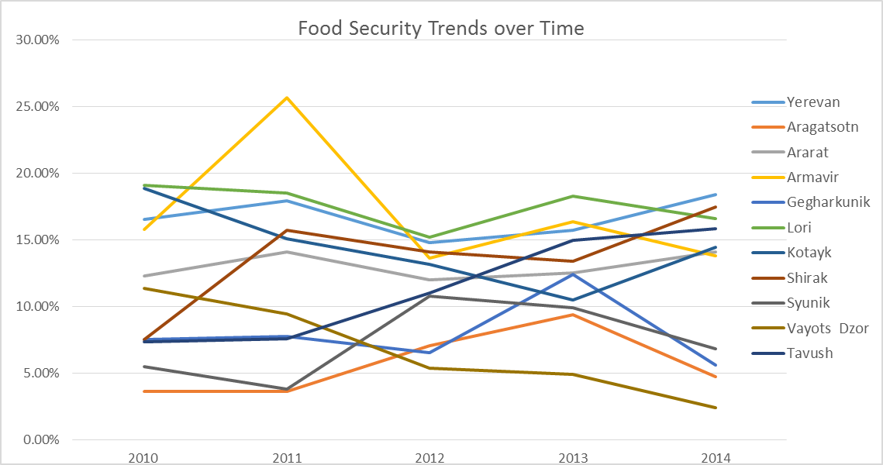The graph below displays the different patterns of vulnerability in each Administrative level (Admin01, Admin02), which are also key to understanding the context of food insecurity and how best to address them programmatically. The horizontal axis shows the year, whilst the vertical axis shows the percentage of people living in each Administrative level (Admin01, Admin02) who were food insecure.

Intra-Annual Variability of Food Insecurity

|  |
| --- |
| <insert 1 file with 2-4 maps showing seasonality of food security here: Total image size 17cm width by 12cm height. Exact dimension of each map 8.5 cm width x 6 cm height, maximum file size 500kb for single file with all 4 maps; use PNG format, not JPEG> |

|  |
| --- |
| Seasonality of food security was analysed using data from source which was available from Year through Year. The original dataset was aggregated to the Administrative level (Admin01, Admin02), and was analysed considering the number of seasons main seasons of names of seasons (respective months). It should be noted that: data caveats/limitations/gaps/sampling issues, etc. The key indicator used was the indicator |

Seasonality of Natural Shocks

|  |
| --- |
| <insert 1 file with 4 maps showing seasonality of shocks here: Total image size 17cm width by 12cm height. Exact dimension of each map 8.5 cm width x 6 cm height, maximum file size 500kb for single file with all 4 maps; use PNG format, not JPEG> |

|  |
| --- |
| Seasonality of natural shocks was analysed using provide details… |

Livelihoods

|  |
| --- |
| <insert livelihoods map here: Exact dimensions 17 cm width x 12 cm height, maximum file size 500kb; use PNG format, not JPEG> |

|  |
| --- |
| An understanding of livelihoods and seasonality informs how shocks may impact households, the times of the year that are most critical for people, and how to select programming interventions. Data on livelihood zones was sourced from Source | Year. |

# Estimated Numbers of Food Insecure People

Longer-term programme planning requires an indication of the number of people who are likely to require assistance. To calculate this, data on the number of people estimated to be food insecure between Year1 and Year5, as reported by source, was tabled. Figures for rural/urban/both population were used. The lowest numbers (in yellow) and the highest numbers (in red) are highlighted:

|  |  |  |  |  |
| --- | --- | --- | --- | --- |
| **Indicator** from **Year 1** to **Year 5** | | | | |
| **Year 1** | **Year 2** | **Year 3** | **Year 4** | **Year 5** |
| Figure | Figure | Figure | Figure | Figure |

The overall average of the number of people estimated as food insecure over the last five years (calculate and insert figure here) reflects the number of people who are either (a) consistently food insecure or (b) have experienced food insecurity at some point as a result of a specific shock or event. This figure can represent an overall longer-term planning estimation.

The average of the two lowest figures recorded over the recall period (calculate and insert figure here) provides an estimate of a core group of people who were consistently food insecure irrespective of whether there were good harvests or not in the last five years, and thus for planning purposes, can reflect an estimate of those *most* *vulnerable* to food insecurity.

The difference between the averages of the two highest figures recorded over the recall period (calculate and insert figure here) and the overall average above reflects the estimated number of *additional* people at risk, who could fall into crisis in the event of a shock (be it natural or man-made) (figure).

In summary, planning estimates (rounded up) would be as follows:

|  |  |
| --- | --- |
| **Long-term planning:** average number of food insecure people in the last reference period | **figure** |
| **Most vulnerable:** *of the above*, estimated number of consistently food insecure people | **figure** |
| **Preparedness planning:** *in addition to the above,*additional number of food insecure in the event of a shock (be it natural or man-made) | **figure** |

***It is essential to note that these are just planning estimates and that actual numbers should be derived from emergency assessments in the event of a crisis and that plans should be adjusted throughout the programming cycle based on assessments that reflect the current situation.***

**Additional Food Insecure**

in the event of a shock

## Food Insecure Population for Long-Term Planning

This analysis is also carried out at the Administrative level (Admin01, Admin02) level, in order to highlight which areas have higher need for long-term planning or preparedness.

|  |
| --- |
| <Insert here the map of long-term average % of food insecure population>  Exact dimensions 17 cm width x 12 cm height, maximum file size 500kb; use PNG format, not JPEG> |

The population figures for long-term planning were mapped by Administrative level (Admin01, Admin02) as a percentage of the total Administrative level (Admin01, Admin02) population, highlighting areas that require longer-term programming to address food insecurity.

Food Insecure Population for Preparedness

|  |
| --- |
| <Insert here the map of number of potential additional food insecure population>  Exact dimensions 17 cm width x 12 cm height, maximum file size 500kb; use PNG format, not JPEG> |

The number of people who could potentially fall into food insecurity and require assistance in the event of a shock were mapped by Administrative level (Admin01, Admin02). The map highlights areas that require greater preparedness measures, or programmes designed to absorb additional vulnerable people.

# Technical Analysis Methodology

## Food security

The ICA food security analysis aims to assess how the chosen indicator values have fluctuated, versus a benchmark, over the time period for which data are available. It assesses the food security trend of each geographic area against the threshold and reclassifies each area using a simple 3-point scale to indicate its food insecurity status (e.g., “low” as 1, “medium” as 2 and “high” as 3). As previously mentioned, in Country the threshold for was set at threshold level.

To assess the food security trend, the ICA food security analysis considers the r**ecurrence above threshold,** measured as the ***number of times*** the area in question has had a food security indicator value equal to or above the threshold.

## Rapid-onset shocks

When using global data, information on the average frequency of events for the time period available is provided for each pixel. This is modelled data and it is not possible to ascertain how many events have actually occurred for any given year or period of years e.g., previous 5 or ten years (this specificity is lost when using modelled data). Furthermore, as frequencies can be very high for a single pixel, it is important to balance this information with a consideration of the total surface area by district that is affected. This approach is outlined below.

When local tabular data is available and specifies the historical number of events per year by district (preferably for the previous 30 years, though a minimum of 20 is acceptable), the total of the events over the period in question is taken and the final reclassification into low, medium and high levels of occurrence described below is based on that figure. When such national data is available, the number of events that occurred in the past five years can also be mapped to highlight areas where recovery activities may be relevant.

When working with spatial global data, the objective is to extract a district-level table from the shock frequency raster (in this case, floods, for ease of reference) that captures (a) the extent of flood areas and (b) the occurrence of floods by pixel. Using **Jenks Natural Breaks** (available through ArcGIS), the range of values for both the surface area affected and the number of occurrences can be broken down into three classes and reclassified as **low**, **medium** or **high** values. These values are cross-tabbed to yield a final classification by district which can itself be reclassified into the 3-point scale (low, medium, high) and mapped (see map presented in Part 2).

Where floods and storms are being considered, the analysis follows the same steps for each hazard independently but findings for each are cross-tabbed again to yield a single consolidated classification.

## Slow-onset shocks

When working with **national level data** that presents the number of drought events that have occurred by year and by district, the range of values defined by the whole time period for which data is available can be broken down into three classes and reclassified as **low**, **medium** or **high** values using **Jenks Natural Breaks** (available in ArcGIS) and subsequently mapped.

When national level data on drought occurrences is not available the “**Number of Poor Growing Seasons (NPGS)**” can be used as a proxy to measure recent exposure to drought. This is done using remote-sensed datasets on the Normalized Difference Vegetation Index (NDVI) or Rainfall Estimates data (RFE) (depending on context). *For more detailed information, please see the ICA Guidance Note on Drought.*

**The analysis.** Preparation and analysis of NDVI data in particular is complex. In essence, multiple raster files that capture NDVI values at specific intervals in time over a number of years are downloaded and filtered for atmospheric interference and other factors that can influence final readings. Once done:

* A **long-term (NDVI) average** of vegetation cover for each growing season is calculated (there may be more than one growing season in a given location).
* The NDVI values for the growing seasons of each of the most recent 5 five years is compared against the benchmark (80% of the long-term average).
* This comparison is expressed as the *number of poor growing seasons (NPGS)* if the more recent values fall below the long-term average.

The basic assumption behind this comparison is that if the vegetation growth in a particular growing season is considerably below the longer-term average this would indicate **water** **stress** or **drought conditions** for vegetation growth in that area.

The results of the above are presented in raster format, where each pixel captures the number of times in the last five years that the NDVI values of the growing seasons were below the long-term average. From this, figures are aggregated to yield an average number of poor growing seasons by district. The range of values for the NPGS is broken down into three classes (**low, medium** and **high**)andmapped.

When RFE, NDVI and/or WRSI data are available, these can be cross-tabbed to yield a merged classification that reflects the impacts of all.

## Land degradation

#### Changes in land cover classes

The current method of analysis for land degradation aims to identify and qualitatively classify recent negative change in land cover classes and deforestation, in particular in areas associated with high recurrence of shocks and food insecurity. The analysis compares the status of land cover classes as measured in 2001 with the present (2012), considering changes on a yearly basis and with a spatial resolution of 500m. Data is sourced from MODIS (NASA) which offers global coverage.

Each of the MODIS standard land cover classes emerging for 2001 and 2012 is given a numerical “ecological value” (the higher the number, the higher the ecological value).

|  |  |  |
| --- | --- | --- |
| **MCD12Q1 class** | **New_Name** | **Eco Value** |
| Evergreen broadleaf forest | Forest | **6** |
| Deciduous broadleaf forest | Forest | **6** |
| Permanent wetlands | Wetland | **6** |
| Closed shrublands | Shrubland | **5** |
| Grasslands | Shrubland | **4** |
| Croplands | Croplands | **3** |
| Barren or sparsely vegetated | Barren or sparsely vegetated | **2** |
| Urban built-up | Urban built-up | **1** |
| Fill value | Fill value | **0** |
| Snow and Ice | Snow and Ice | **0** |

Changes over time are expressed as the difference between the initial (2001) and final (2012) land cover class values which can result in a range of values from +6 to -6 where **negative** values indicate a deterioration in the ecological value of the land, **zero** indicates no change in land cover and **positive** values indicate improvement in the ecological value.

The average change is calculated for each district (or other administrative area as defined by the analysis), taking into consideration the extent of both positive and negative change. The range of **positive** values is broken down into three classes using Natural Breaks and the same is done for the **negative** values.

#### Erosion propensity

The main indicator utilised for the analysis of soil erosion emerges from a simplified version of the Universal Soil Loss Equation (USLE) which is widely recognised in the sector as a proxy or means of estimating erosion propensity. In its original form it is expressed as:

Erosion = R * K * Sl * C * P

Where “R” stands for rainfall, “K” stands for soil property in lithological terms, “S” stands for slope length, “C” stands for predominant land use and “P” indicates a protective factor, such as the presence of infrastructure apt to decrease soil erosion. . In general, data on the “P” factor is hard to find, so a simplified version has been developed which relies on four key elements:

* Rainfall incidence, WorldClim, 1960 - 1990 (~1 km resolution)
* Soil lithology calculated based on the FAO Digital Soil Map of the World v3.6, 2003
* Land cover extracted from NASA MODIS MCD12Q1 product (~250m resolution)
* Slope length calculated by SAGA-GIS using NASA SRTM digital elevation model (500m resolution).

*For more information on the actual elaboration of the raster files and final erosion propensity calculation, please contact OSEP-GIS Unit.*

The resulting product provides an estimate of the potential soil loss, in tons/ha per year. All soil loss above 5 tons/ha per year is considered as significant, and the percentage of the territory in each district (or unit of measure) that experiences this level of erosion propensity is calculated.

## Nutrition

<insert appropriate methods description if used>

## Livelihoods

<insert appropriate methods description if used>

## Variability

#### Food Insecurity

##### Inter-annual (across year) food security variability

The variability/stability of food security from year to year is measured in terms of how much – and to what extent – the food security indicator values for the area in question have fluctuated over time (using the standard deviation of each district’s food security values, relative to the district mean). These values were then classified into terciles to highlight areas with relatively Low, Medium and High variability. This helps determine the stability or lack of stability of the food security situation and can help highlight shocks and/or seasonality.

##### Intra-annual variability (seasonality)

To carry out a seasonal analysis of food security, the data from various food security rounds was grouped according to how the months in which they were collected align with the seasons in the seasonal calendar and/or local knowledge of the seasons in the country (see seasonality section). Where seasons vary across different parts of the country, it may be appropriate to also aggregate data by region.

The food security analysis was carried out on each subset of data using the same methodology as used for the basic food security analysis (i.e. calculating the percentage of recurrences above the chosen threshold) and results were mapped as presented in the above-referenced section.

#### Natural shocks

The following methods build on the information explained in the section above on slow-onset shock (primarily drought), explaining how drought-related information can be interpreted from a seasonal perspective.

##### Inter-annual (year-to-year) variability in vegetation growth

In most cases, vegetation growth levels are assessed using the normalized difference vegetation index (NDVI). When looking at historical trends, NDVI values are plotted for various intervals during the year, for each year. This results in a series of peaks and dips that reflect when vegetation is scarce (dips/dry seasons) and abundant (peaks/wet seasons). The variability refers to the amount of change between the peaks (and dips) across the years. If variability across years is low, the levels of scarce vegetation and abundant vegetation that can be expected in a given context at given times are relatively stable (or predictable). If variability is high, this would indicate less predictability or stability in the vegetation levels over time, possibly indicating high climate variability.

##### Intra-annual (within years) variability in vegetation growth

At the same time, the NDVI curve for a single year will also reveal variability within the year, illustrating the degree of change between the lowest and highest NDVI values (in practice, changes between periods of dryness and wetness). For example, in tropical areas where vegetation coverage is normally abundant, variability is likely to be quite low whereas areas that experience distinct dry and wet seasons and typically have less consistent vegetative cover will have greater variability.

Overlaying livelihood boundaries, settlements and population density on seasonality maps can highlight how and where the seasonality is most likely to affect people.

##### Number of poor growing seasons

Another useful piece of seasonal information is to conduct the number of poor growing seasons analysis separately for each growing season. Doing so involves counting the number of times the average NDVI value of each season fell below the benchmark (80% of the long-term average NDVI value). In practical terms, this can be seen as how frequently vegetation has suffered and not grown for each season (presumably due to a lack of water/moisture) compared to the norm.

# Data Sources

<Insert the Data Sources Checklist here – select **Insert – Object – Create from File** and locate the Checklist on your computer. Or copy and paste from another file. Format as needed, noting that blue used in this document is R/G/B = 0/129/195, and using headings appropriate noting Heading 1 and Heading 2 will appear in the Table of contents>

### 

# Data tables

## Final ICA Collecting Table

<insert data table and format as needed noting that blue used in this document is R/G/B = 0/129/195. Sort districts/units of analysis by Category/Area for better user-friendliness >

## Nutrition Data Table

<insert data table for nutrition (and any other data mapped that was not available at the unit of analysis) and format as needed noting that blue used in this document is R/G/B = 0/129/195. >